***Bahria University Karachi Campus***

*Department of Software Engineering*



**DBMS PROJECT REPORT**

|  |
| --- |
| **Course TitleCourse Title::** **Database Management System** **Database Management System**  **Course code:Course code:** **CSL 220** **CSL 220**  **Course instructor:Course instructor:** **Engr**  **Engr Laraib SiddiqueLaraib Siddique**  **Lab iLab nstructorinstructor:**: **E** **ngr Ayesha KhanEngr Ayesha Khan** |

**HOSPITAL MANAGEMENT SYSTEM**

**Section: BSE 4B**

**Mustufa (team leader) 02-131202-012**

**Abdul Qudoos 02-131202-033 Syed Abdullah 02-131202-066**

**Farhan Ali 02-131192-063**

# TABLE OF CONTENT

ACKNOWLEDGE……………………………………………………………….02

ABTRACT………………………………………………………………………..02

INTRODUCTION………………………………………………………………..02 SCOPE……………………………………………………………………………03

CODE…………………………………………………………………………….03

USECASE………………………………………………………………………..63

DB DIAGRAM…………………………………………………………………...64

TABLES…………………………………………………………………………..64

TECHNOLOGIES……………………………………………………………...…65

SOLUTION SHOTS……………………………………………..……………….66

REFERENCES……………………………………………………………...…….67

**ACKNOWLEDGEMENT**

I would like to extend my sincere thanks to all of my team members. I am highly indebted to ma’am Ayesha for their guidance and constant supervision as well as for providing necessary information regarding the project & also for their support in completing this hospital management system.

**ABSTRACT**

The System consists of two modules Doctors and Patients. The system consists of storing information related to Doctors and Patients. The front end (user interface) is designed with using GUI generator at visual studio. Architecture used in this system is MVC. The modules are designed using C# and Asp.net. For storage services we use SQL Server.

**INTRODUCTION**

As we feel some difficulties in visiting hospital and realize some gaps that could be remove through online system. For this we have designed a basic online hospital management system to feel those gaps. We have designed this application on c# language and applied different technologies to make it more efficient. To overcome storage headache we have also provide storage services connected with our online system. In this system two users doctors and patient can login into the system. Doctors can prescribe the medicines to the patient and patient can view it. Patient can also book an online appointment which help patient to save his/her important time.

In this we have created multiple tables using SQL database helping in quick access to information when needed.

**PROJECT SCOPE**

This system is designed to automate hospital daily operations to reduce operation costs and time. This Management System is the best solution for all general requirements of Hospital and provide effective storage services of information related to Patients and Doctors. This system will increase no of patients by 25%. Also remove the communication wall between doctor and patient.

**PROJECT MODULES**

**VIEWS:**

**Doctors:**

<%@ MASTER LANGUAGE="C#" AUTOEVENTWIREUP="TRUE"

CODEBEHIND="DOCTORMASTER.MASTER.CS"

INHERITS="EHOSPITALMS.VIEWS.DOCTORS.DOCTORMASTER" %>

<!DOCTYPE HTML>

<HTML>

<HEAD RUNAT="SERVER">

<TITLE></TITLE>

<LINK REL="STYLESHEET" HREF="../../LIBS/BOOTSTRAP/CSS/BOOTSTRAP.MIN.CSS" />

<ASP:CONTENTPLACEHOLDER ID="HEAD" RUNAT="SERVER">

</ASP:CONTENTPLACEHOLDER>

</HEAD>

<BODY>

<FORM ID="FORM1" RUNAT="SERVER">

<DIV>

<NAV CLASS="NAVBAR NAVBAR-EXPAND-LG NAVBAR-LIGHT BG-LIGHT">

<A CLASS="NAVBAR-BRAND" HREF="#">CLINIC</A>

<BUTTON CLASS="NAVBAR-TOGGLER" TYPE="BUTTON" DATA-TOGGLE="COLLAPSE"

DATA-TARGET="#NAVBARSUPPORTEDCONTENT" ARIA-

CONTROLS="NAVBARSUPPORTEDCONTENT" ARIA-EXPANDED="FALSE" ARIA-LABEL="TOGGLE

NAVIGATION">

<SPAN CLASS="NAVBAR-TOGGLER-ICON"></SPAN>

</BUTTON>

<DIV CLASS="COLLAPSE NAVBAR-COLLAPSE" ID="NAVBARSUPPORTEDCONTENT">

<UL CLASS="NAVBAR-NAV MR-AUTO">

<LI CLASS="NAV-ITEM">

<A CLASS="NAV-LINK" HREF="VISIT.ASPX">VISIT</A>

</LI>

<LI CLASS="NAV-ITEM">

<FORM>

<ASP:LINKBUTTON ID="LINKBUTTON1" RUNAT="SERVER" CSSCLASS="NAV-

LINK" ONCLICK="LINKBUTTON1_CLICK1">LOGOUT</ASP:LINKBUTTON>

</FORM>

</LI>

</UL>

</DIV>

</NAV>

<ASP:CONTENTPLACEHOLDER ID="MYBODY" RUNAT="SERVER">

</ASP:CONTENTPLACEHOLDER>

</DIV>

</FORM>

</BODY>

</HTML>

///////////////////////////////////////////////////////////////////////////////////////////////////////////////////////////////////////////////////

USING SYSTEM;

USING SYSTEM.COLLECTIONS.GENERIC;

USING SYSTEM.LINQ;

USING SYSTEM.WEB;

USING SYSTEM.WEB.UI;

USING SYSTEM.WEB.UI.WEBCONTROLS;

NAMESPACE EHOSPITALMS.VIEWS.DOCTORS

{

PUBLIC PARTIAL CLASS DOCTORMASTER : SYSTEM.WEB.UI.MASTERPAGE

{

PROTECTED VOID LINKBUTTON1_CLICK1(OBJECT SENDER, EVENTARGS E)

{

STRING R_URL = "../GUEST/HOME.ASPX";

MODELS.FUNCTIONS.STORAGE.STORE("USERID", "");

RESPONSE.REDIRECT(R_URL);

}

PROTECTED VOID PAGE_LOAD(OBJECT SENDER, EVENTARGS E)

{

}

}

}

////////////////////////////////////////////////////////////////////////////////////////////////////////////////////////////////////////////// //------------------------------------------------------------------------------

// <AUTO-GENERATED>

// THIS CODE WAS GENERATED BY A TOOL.

//

// CHANGES TO THIS FILE MAY CAUSE INCORRECT BEHAVIOR AND WILL BE LOST IF

// THE CODE IS REGENERATED.

// </AUTO-GENERATED>

//------------------------------------------------------------------------------

NAMESPACE EHOSPITALMS.VIEWS.DOCTORS

{

PUBLIC PARTIAL CLASS DOCTORMASTER

{

/// <SUMMARY>

/// HEAD CONTROL.

/// </SUMMARY>

/// <REMARKS>

/// AUTO-GENERATED FIELD.

/// TO MODIFY MOVE FIELD DECLARATION FROM DESIGNER FILE TO CODE-BEHIND FILE.

/// </REMARKS>

PROTECTED GLOBAL::SYSTEM.WEB.UI.WEBCONTROLS.CONTENTPLACEHOLDER HEAD;

/// <SUMMARY>

/// FORM1 CONTROL.

/// </SUMMARY>

/// <REMARKS>

/// AUTO-GENERATED FIELD.

/// TO MODIFY MOVE FIELD DECLARATION FROM DESIGNER FILE TO CODE-BEHIND FILE.

/// </REMARKS>

PROTECTED GLOBAL::SYSTEM.WEB.UI.HTMLCONTROLS.HTMLFORM FORM1;

/// <SUMMARY>

/// LINKBUTTON1 CONTROL.

/// </SUMMARY>

/// <REMARKS>

/// AUTO-GENERATED FIELD.

/// TO MODIFY MOVE FIELD DECLARATION FROM DESIGNER FILE TO CODE-BEHIND FILE.

/// </REMARKS>

PROTECTED GLOBAL::SYSTEM.WEB.UI.WEBCONTROLS.LINKBUTTON LINKBUTTON1;

/// <SUMMARY>

/// MYBODY CONTROL.

/// </SUMMARY>

/// <REMARKS>

/// AUTO-GENERATED FIELD.

/// TO MODIFY MOVE FIELD DECLARATION FROM DESIGNER FILE TO CODE-BEHIND FILE.

/// </REMARKS>

PROTECTED GLOBAL::SYSTEM.WEB.UI.WEBCONTROLS.CONTENTPLACEHOLDER MYBODY;

}

}

//////////////////////////////////////////////////////////////////////////////////////////////////////////////

<%@ PAGE TITLE="" LANGUAGE="C#"

MASTERPAGEFILE="~/VIEWS/DOCTORS/DOCTORMASTER.MASTER" AUTOEVENTWIREUP="TRUE"

CODEBEHIND="PRESCRIPTION.ASPX.CS"

INHERITS="EHOSPITALMS.VIEWS.DOCTORS.PRESCRIPTION"

ENABLEEVENTVALIDATION="FALSE" %>

<ASP:CONTENT ID="CONTENT1" CONTENTPLACEHOLDERID="HEAD" RUNAT="SERVER">

</ASP:CONTENT>

<ASP:CONTENT ID="CONTENT2" CONTENTPLACEHOLDERID="MYBODY" RUNAT="SERVER">

<DIV CLASS="CONTAINER-FLUID">

<DIV CLASS="ROW">

<DIV CLASS="COL-MD-4">

<H2>PRESCRIPTION DETAIL</H2>

<BR /><BR /><BR />

<FORM>

<DIV CLASS="MB-3">

<LABEL FOR="PRESPATIENTCB">PATIENT</LABEL>

<ASP:DROPDOWNLIST ID="PRESPATIENTCB" RUNAT="SERVER" CLASS="FORM-

CONTROL">

</ASP:DROPDOWNLIST>

</DIV>

<DIV CLASS="MB-3">

<LABEL FOR="PRESPRESCRIPTIONTB">PRESCRIPTION</LABEL>

<INPUT TYPE="TEXT" CLASS="FORM-CONTROL" ID="PRESPRESCRIPTIONTB"

PLACEHOLDER="ENTER PRESCRIPTION" RUNAT="SERVER" />

</DIV>

<DIV CLASS="MB-3">

<LABEL FOR="PRESCOSTTB">COST</LABEL>

<INPUT TYPE="TEXT" CLASS="FORM-CONTROL" ID="PRESCOSTTB"

PLACEHOLDER="ENTER COST" RUNAT="SERVER" />

</DIV>

<DIV CLASS="D-GRID">

<LABEL RUNAT="SERVER" ID="ERRMSG" CLASS="TEXT-DANGER"></LABEL>

<BR />

<ASP:BUTTON ID="ADDBTN" RUNAT="SERVER" TEXT="SAVE PRESCRIPTION"

CLASS="BTN BTN-WARNING BTN-BLOCK TEXT-WHITE" ONCLICK="ADDBTN_CLICK" />

</DIV>

</FORM>

</DIV>

<DIV CLASS="COL-MD-8">

<DIV CLASS="ROW">

<DIV CLASS="COL">

<IMG SRC="../../ASSETS/IMAGES/DOCTOR.PNG" WIDTH="100%" CLASS="ROUNDED-3" />

</DIV>

</DIV>

<DIV CLASS="ROW">

<DIV CLASS="COL">

<H1>PRESCRIPTION DETAILS</H1>

<ASP:GRIDVIEW ID="PRESCRIPTIONSINFO" CLASS="TABLE TABLE-HOVER"

RUNAT="SERVER" AUTOGENERATESELECTBUTTON="TRUE" CELLPADDING="4"

FORECOLOR="#333333" GRIDLINES="NONE">

<ALTERNATINGROWSTYLE BACKCOLOR="WHITE" />

<EDITROWSTYLE BACKCOLOR="#2461BF" />

<FOOTERSTYLE BACKCOLOR="#507CD1" FONT-BOLD="TRUE"

FORECOLOR="WHITE" />

<HEADERSTYLE BACKCOLOR="#507CD1" FONT-BOLD="TRUE" FORECOLOR="WHITE" />

<PAGERSTYLE BACKCOLOR="#2461BF" FORECOLOR="WHITE"

HORIZONTALALIGN="CENTER" />

<ROWSTYLE BACKCOLOR="#EFF3FB" />

<SELECTEDROWSTYLE BACKCOLOR="#D1DDF1" FONT-BOLD="TRUE"

FORECOLOR="#333333" />

<SORTEDASCENDINGCELLSTYLE BACKCOLOR="#F5F7FB" /> <SORTEDASCENDINGHEADERSTYLE BACKCOLOR="#6D95E1" />

<SORTEDDESCENDINGCELLSTYLE BACKCOLOR="#E9EBEF" />

<SORTEDDESCENDINGHEADERSTYLE BACKCOLOR="#4870BE" />

</ASP:GRIDVIEW>

</DIV>

</DIV>

</DIV>

</DIV>

</DIV>

</ASP:CONTENT>

//////////////////////////////////////////////////////////////////////////////////////////////////////////////////////////////////

USING SYSTEM;

USING SYSTEM.COLLECTIONS.GENERIC;

USING SYSTEM.LINQ;

USING SYSTEM.WEB;

USING SYSTEM.WEB.UI;

USING SYSTEM.WEB.UI.WEBCONTROLS;

NAMESPACE EHOSPITALMS.VIEWS.DOCTORS

{

PUBLIC PARTIAL CLASS PRESCRIPTION : SYSTEM.WEB.UI.PAGE

{

MODELS.FUNCTIONS CONNECTION;

PRIVATE VOID SHOWPRESCRIPTIONS()

{

STRING QUERY = "SELECT * FROM PRESCRIPTION"; PRESCRIPTIONSINFO.DATASOURCE = CONNECTION.GETDATA(QUERY); PRESCRIPTIONSINFO.DATABIND();

}

PRIVATE VOID GETPATIENT()

{

STRING QUERY = "SELECT * FROM PATIENT WHERE [PATIENT ID] IN (SELECT [PATIENT ID]

FROM APPOINTMENTS WHERE [DOCTOR ID] = '" +SESSION["UID"] AS STRING+"' AND

[APPOINTMENT DATE] = '" + SESSION["DATE"] AS STRING +"')";

PRESPATIENTCB.DATATEXTFIELD = CONNECTION.GETDATA(QUERY).COLUMNS["PATIENT

NAME"].TOSTRING();

PRESPATIENTCB.DATAVALUEFIELD = CONNECTION.GETDATA(QUERY).COLUMNS["PATIENT ID"].TOSTRING();

PRESPATIENTCB.DATASOURCE = CONNECTION.GETDATA(QUERY); PRESPATIENTCB.DATABIND();

}

PROTECTED VOID PAGE_LOAD(OBJECT SENDER, EVENTARGS E)

{

CONNECTION = NEW MODELS.FUNCTIONS();

SHOWPRESCRIPTIONS();

//GETTEST();

GETPATIENT();

}

PROTECTED VOID ADDBTN_CLICK(OBJECT SENDER, EVENTARGS E)

{

TRY

{

INT DOCTOR = 301;

STRING PATIENT = PRESPATIENTCB.SELECTEDVALUE.TOSTRING();

STRING MEDICINE = PRESPRESCRIPTIONTB.VALUE;

STRING COST = PRESCOSTTB.VALUE;

STRING QUERY = "INSERT INTO PRESCRIPTIONTBL VALUES({0},{1},'{2}',{3},{4})";

QUERY = STRING.FORMAT(QUERY, DOCTOR, PATIENT, MEDICINE, COST);

CONNECTION.SETDATA(QUERY);

SHOWPRESCRIPTIONS();

ERRMSG.INNERTEXT = "PRESCRIPTION ADDED!!!!";

PRESPRESCRIPTIONTB.VALUE = "";

PRESCOSTTB.VALUE = "";

PRESPATIENTCB.SELECTEDINDEX = -1;

}

CATCH (EXCEPTION EX)

{

ERRMSG.INNERTEXT = EX.MESSAGE;

}

}

}

}

///////////////////////////////////////////////////////////////////////////////////////////////////////////////////

<%@ PAGE TITLE="" LANGUAGE="C#"

MASTERPAGEFILE="~/VIEWS/DOCTORS/DOCTORMASTER.MASTER" AUTOEVENTWIREUP="TRUE" CODEBEHIND="VISIT.ASPX.CS" INHERITS="EHOSPITALMS.VIEWS.DOCTORS.VISIT"

ENABLEEVENTVALIDATION="FALSE" %>

<ASP:CONTENT ID="CONTENT1" CONTENTPLACEHOLDERID="HEAD" RUNAT="SERVER">

</ASP:CONTENT>

<ASP:CONTENT ID="CONTENT2" CONTENTPLACEHOLDERID="MYBODY" RUNAT="SERVER">

<DIV CLASS="CONTAINER-FLUID">

<DIV CLASS="ROW">

<DIV CLASS="COL-MD-4">

<H2>VISIT DETAIL</H2>

<BR />

<BR />

<BR />

<DIV CLASS="MB-3">

<LABEL FOR="VISITDATETB">DATE OF VISIT</LABEL>

<INPUT TYPE="DATE" CLASS="FORM-CONTROL" ID="VISITDATETB"

PLACEHOLDER="ENTER VISIT DATE" RUNAT="SERVER" /><BR /><BR />

<LABEL FOR="VISITFEESTB">FEES</LABEL>

<INPUT TYPE="TEXT" CLASS="FORM-CONTROL" ID="VISITFEESTB"

PLACEHOLDER="ENTER VISIT FEES" RUNAT="SERVER" /><BR /><BR />

</DIV>

<DIV CLASS="D-GRID">

<LABEL RUNAT="SERVER" ID="ERRMSG" CLASS="TEXT-DANGER"></LABEL>

<BR />

<ASP:BUTTON ID="ADDBTN" RUNAT="SERVER" TEXT="SAVE" CLASS="BTN BTN-

WARNING TEXT-WHITE" ONCLICK="ADDBTN_CLICK" />

<ASP:BUTTON ID="BUTTON1" RUNAT="SERVER" TEXT="DELETE" CLASS="BTN BTN-

DANGER TEXT-WHITE" ONCLICK="DELETEBTN_CLICK" />

</DIV>

</DIV>

<DIV CLASS="COL-MD-8">

<DIV CLASS="ROW">

<DIV CLASS="COL">

<IMG SRC="../../ASSETS/IMAGES/DOCTOR.PNG" WIDTH="100%" CLASS="ROUNDED-3" />

</DIV>

</DIV>

<DIV CLASS="ROW">

<DIV CLASS="COL">

<H1>VISIT DETAILS</H1>

<ASP:GRIDVIEW ID="VISITSINFO" CLASS="TABLE TABLE-HOVER" RUNAT="SERVER"

AUTOGENERATESELECTBUTTON="TRUE" CELLPADDING="4" FORECOLOR="#333333"

GRIDLINES="NONE" ONSELECTEDINDEXCHANGED="VISITSINFO_SELECTEDINDEXCHANGED">

<ALTERNATINGROWSTYLE BACKCOLOR="WHITE" />

<%-- <COLUMNS>

<ASP:BUTTONFIELD BUTTONTYPE="BUTTON" COMMANDNAME="UPDATE"

HEADERTEXT="APPROVE" SHOWHEADER="TRUE" TEXT="APPROVE" CONTROLSTYLE-

BACKCOLOR="GREEN"/>

</COLUMNS>--%>

<EDITROWSTYLE BACKCOLOR="#2461BF" />

<FOOTERSTYLE BACKCOLOR="#507CD1" FONT-BOLD="TRUE"

FORECOLOR="WHITE" />

<HEADERSTYLE BACKCOLOR="#507CD1" FONT-BOLD="TRUE" FORECOLOR="WHITE" />

<PAGERSTYLE BACKCOLOR="#2461BF" FORECOLOR="WHITE"

HORIZONTALALIGN="CENTER" />

<ROWSTYLE BACKCOLOR="#EFF3FB" />

<SELECTEDROWSTYLE BACKCOLOR="#D1DDF1" FONT-BOLD="TRUE"

FORECOLOR="#333333" />

<SORTEDASCENDINGCELLSTYLE BACKCOLOR="#F5F7FB" />

<SORTEDASCENDINGHEADERSTYLE BACKCOLOR="#6D95E1" />

<SORTEDDESCENDINGCELLSTYLE BACKCOLOR="#E9EBEF" />

<SORTEDDESCENDINGHEADERSTYLE BACKCOLOR="#4870BE" />

</ASP:GRIDVIEW>

</DIV>

</DIV>

</DIV>

</DIV>

</DIV>

</ASP:CONTENT>

/////////////////////////////////////////////////////////////////////////////////////////////////////////////////////////////////

USING SYSTEM;

USING SYSTEM.COLLECTIONS.GENERIC;

USING SYSTEM.LINQ;

USING SYSTEM.WEB;

USING SYSTEM.WEB.UI;

USING SYSTEM.WEB.UI.WEBCONTROLS;

NAMESPACE EHOSPITALMS.VIEWS.DOCTORS

{

PUBLIC PARTIAL CLASS VISIT : SYSTEM.WEB.UI.PAGE

{

MODELS.FUNCTIONS CONNECTION;

PROTECTED VOID PAGE_LOAD(OBJECT SENDER, EVENTARGS E)

{

CONNECTION = NEW MODELS.FUNCTIONS();

SHOWVISITS();

}

PRIVATE VOID SHOWVISITS()

{

STRING QUERY = "SELECT * FROM VISIT WHERE [DOCTORID] = '" + SESSION["UID"] AS

STRING +"' AND DATE >= GETDATE()";

VISITSINFO.DATASOURCE = CONNECTION.GETDATA(QUERY);

VISITSINFO.DATABIND();

}

PUBLIC OVERRIDE VOID VERIFYRENDERINGINSERVERFORM(CONTROL CONTROL)

{

}

INT KEY = 0;

PROTECTED VOID DELETEBTN_CLICK(OBJECT SENDER, EVENTARGS E)

{

TRY

{

STRING QUERY = "DELETE FROM VISIT WHERE VISITID = {0}";

QUERY = STRING.FORMAT(QUERY, VISITSINFO.SELECTEDROW.CELLS[1].TEXT);

CONNECTION.SETDATA(QUERY);

SHOWVISITS();

ERRMSG.INNERTEXT = "VISIT DELETED!!!";

KEY = 0;

VISITDATETB.VALUE = "";

}

CATCH (EXCEPTION EX)

{

ERRMSG.INNERTEXT = EX.MESSAGE;

}

}

PROTECTED VOID ADDBTN_CLICK(OBJECT SENDER, EVENTARGS E)

{

TRY

{

STRING VISITDATE = VISITDATETB.VALUE;

STRING QUERY = "INSERT INTO VISIT VALUES({0},'{1}',{2})";

VAR ID = MODELS.FUNCTIONS.STORAGE.GET("USERID").TOSTRING();

QUERY = STRING.FORMAT(QUERY, CONVERT.TOINT32(ID),

VISITDATE.TOSTRING(),VISITFEESTB.VALUE.TOSTRING()); CONNECTION.SETDATA(QUERY);

SHOWVISITS();

ERRMSG.INNERTEXT = "VISIT ADDED!!!!";

VISITDATETB.VALUE = "";

}

CATCH (EXCEPTION EX)

{

ERRMSG.INNERTEXT = EX.MESSAGE;

}

}

PROTECTED VOID VISITSINFO_SELECTEDINDEXCHANGED(OBJECT SENDER, EVENTARGS E)

{

IF

(CONVERT.TODATETIME(VISITSINFO.SELECTEDROW.CELLS[3].TEXT).DATE.TOSTRING("DD/MM/YY

YY") != DATETIME.NOW.TOSTRING("DD/MM/YYYY")) {

ERRMSG.INNERTEXT = "TODAY IS NOT THE DAY FOR YOUR VISIT";

}

ELSE {

SESSION["UID"] = SESSION["UID"] AS STRING;

SESSION["DATE"] = VISITSINFO.SELECTEDROW.CELLS[3].TEXT;

RESPONSE.REDIRECT("./PRESCRIPTION.ASPX");

}

}

}

}

////////////////////////////////////////////////////////////////////////////////////////////////////////////////////////

//------------------------------------------------------------------------------

// <AUTO-GENERATED>

// THIS CODE WAS GENERATED BY A TOOL.

//

// CHANGES TO THIS FILE MAY CAUSE INCORRECT BEHAVIOR AND WILL BE LOST IF

// THE CODE IS REGENERATED.

// </AUTO-GENERATED>

//------------------------------------------------------------------------------

NAMESPACE EHOSPITALMS.VIEWS.DOCTORS

{

PUBLIC PARTIAL CLASS VISIT

{

/// <SUMMARY>

/// VISITDATETB CONTROL.

/// </SUMMARY>

/// <REMARKS>

/// AUTO-GENERATED FIELD.

/// TO MODIFY MOVE FIELD DECLARATION FROM DESIGNER FILE TO CODE-BEHIND FILE.

/// </REMARKS>

PROTECTED GLOBAL::SYSTEM.WEB.UI.HTMLCONTROLS.HTMLINPUTGENERICCONTROL

VISITDATETB;

/// <SUMMARY>

/// VISITFEESTB CONTROL.

/// </SUMMARY>

/// <REMARKS>

/// AUTO-GENERATED FIELD.

/// TO MODIFY MOVE FIELD DECLARATION FROM DESIGNER FILE TO CODE-BEHIND FILE.

/// </REMARKS>

PROTECTED GLOBAL::SYSTEM.WEB.UI.HTMLCONTROLS.HTMLINPUTTEXT VISITFEESTB;

/// <SUMMARY>

/// ERRMSG CONTROL.

/// </SUMMARY>

/// <REMARKS>

/// AUTO-GENERATED FIELD.

/// TO MODIFY MOVE FIELD DECLARATION FROM DESIGNER FILE TO CODE-BEHIND FILE.

/// </REMARKS>

PROTECTED GLOBAL::SYSTEM.WEB.UI.HTMLCONTROLS.HTMLGENERICCONTROL ERRMSG;

/// <SUMMARY>

/// ADDBTN CONTROL.

/// </SUMMARY>

/// <REMARKS>

/// AUTO-GENERATED FIELD.

/// TO MODIFY MOVE FIELD DECLARATION FROM DESIGNER FILE TO CODE-BEHIND FILE.

/// </REMARKS>

PROTECTED GLOBAL::SYSTEM.WEB.UI.WEBCONTROLS.BUTTON ADDBTN;

/// <SUMMARY>

/// BUTTON1 CONTROL.

/// </SUMMARY>

/// <REMARKS>

/// AUTO-GENERATED FIELD.

/// TO MODIFY MOVE FIELD DECLARATION FROM DESIGNER FILE TO CODE-BEHIND FILE.

/// </REMARKS>

PROTECTED GLOBAL::SYSTEM.WEB.UI.WEBCONTROLS.BUTTON BUTTON1;

/// <SUMMARY>

/// VISITSINFO CONTROL.

/// </SUMMARY>

/// <REMARKS>

/// AUTO-GENERATED FIELD.

/// TO MODIFY MOVE FIELD DECLARATION FROM DESIGNER FILE TO CODE-BEHIND FILE.

/// </REMARKS>

PROTECTED GLOBAL::SYSTEM.WEB.UI.WEBCONTROLS.GRIDVIEW VISITSINFO;

}

}

////////////////////////////////////////////////////////////////////////////////////////////////////////////////

**VIEWS/GUEST:**

<%@ PAGE LANGUAGE="C#" AUTOEVENTWIREUP="TRUE" CODEBEHIND="HOME.ASPX.CS" INHERITS="EHOSPITALMS.VIEWS.GUEST.HOME" %>

<!DOCTYPE HTML>

<HTML XMLNS="HTTP://WWW.W3.ORG/1999/XHTML">

<HEAD RUNAT="SERVER">

<TITLE></TITLE>

<LINK REL="STYLESHEET" HREF="../../LIBS/BOOTSTRAP/CSS/BOOTSTRAP.MIN.CSS" />

<LINK REL="STYLESHEET" HREF="../../LIBS/BOOTSTRAP/JS/BOOTSTRAP.MIN.JS"

</HEAD>

<BODY>

<%--<FORM ID="FORM1" RUNAT="SERVER">

<DIV>

</DIV>

</FORM>--%>

<DIV CLASS="CONTAINER-FLUID">

<NAV CLASS="NAVBAR NAVBAR-EXPAND-LG NAVBAR-LIGHT BG-LIGHT">

<A CLASS="NAVBAR-BRAND" HREF="#">CLINIC</A>

<BUTTON CLASS="NAVBAR-TOGGLER" TYPE="BUTTON" DATA-TOGGLE="COLLAPSE"

DATA-TARGET="#NAVBARSUPPORTEDCONTENT" ARIA-

CONTROLS="NAVBARSUPPORTEDCONTENT" ARIA-EXPANDED="FALSE" ARIA-LABEL="TOGGLE

NAVIGATION">

<SPAN CLASS="NAVBAR-TOGGLER-ICON"></SPAN>

</BUTTON>

<DIV CLASS="COLLAPSE NAVBAR-COLLAPSE" ID="NAVBARSUPPORTEDCONTENT">

<UL CLASS="NAVBAR-NAV MR-AUTO">

<LI CLASS="NAV-ITEM">

<A CLASS="NAV-LINK" HREF="../LOGIN.ASPX">LOGIN</A>

</LI>

</UL>

</DIV>

</NAV>

<DIV CLASS="ROW" STYLE="BACKGROUND-IMAGE: URL(../../ASSETS/IMAGES/HOSPITAL.PNG);

HEIGHT: 500PX; BACKGROUND-SIZE: COVER;">

<DIV CLASS="COL-MD-2">

</DIV>

<DIV CLASS="COL-MD-5">

<DIV CLASS="ROW" STYLE="HEIGHT:100PX"></DIV>

<H2>YOUR HEALTH IS OUR ONLY PRIORITY</H2>

<H2>ALWAYS SERVING YOU AND TAKE CARE</H2>

<P CLASS="H6">OUR CLINIC HAS BEEN CREATED IN 2022 BY A GROUP OF PERSONS

WHO WANTED TO</P>

<P CLASS="H6">REALLY TAKE CARE OF THE HEALTH OF THE POPULATION</P> <BR />

<BUTTON CLASS="BTN BTN-PRIMARY">CONTACT US</BUTTON>

<BUTTON CLASS="BTN BTN-LIGHT BORDER-PRIMARY TEXT-PRIMARY BG-

TRANSPARENT">FEED BACK</BUTTON>

</DIV>

</DIV>

<DIV CLASS="ROW BG-PRIMARY" STYLE="PADDING: 25PX">

<DIV CLASS="ROW" STYLE="HEIGHT: 20PX"></DIV>

<DIV CLASS="COL-MD-3 BG-LIGHT OFFSET-1 ROUNDED-3">

<DIV CLASS="ROW">

<DIV CLASS="COL-2 MT-2">

<IMG SRC="../../ASSETS/IMAGES/LAB_ITEMS.PNG"/>

</DIV>

<DIV CLASS="COL-7">

<H5 CLASS="TEXT-CENTER">SURGERY</H5>

<P CLASS="H6">THE CLINIC HAS A SURGERY DEPARTMENT WITH HIGHLY QUALIFIED

DOCTORS</P>

</DIV>

</DIV>

<DIV CLASS="ROW" STYLE="HEIGHT: 20PX"></DIV>

</DIV>

<DIV CLASS="COL-MD-3 BG-LIGHT OFFSET-1 ROUNDED-3">

<DIV CLASS="ROW">

<DIV CLASS="COL-2 MT-2">

<IMG SRC="../../ASSETS/IMAGES/LAB_ITEMS.PNG"/>

</DIV>

<DIV CLASS="COL-7">

<H5 CLASS="TEXT-CENTER">UROLOGY</H5>

<P CLASS="H6">THE CLINIC HAS A SURGERY DEPARTMENT WITH HIGHLY QUALIFIED

DOCTORS</P>

</DIV>

</DIV>

</DIV>

<DIV CLASS="COL-MD-3 BG-LIGHT OFFSET-1 ROUNDED-3">

<DIV CLASS="ROW">

<DIV CLASS="COL-2 MT-2">

<IMG SRC="../../ASSETS/IMAGES/LAB_ITEMS.PNG"/>

</DIV>

<DIV CLASS="COL-7">

<H5 CLASS="TEXT-CENTER">OPHTALMOLOGY</H5>

<P CLASS="H6">THE CLINIC HAS A SURGERY DEPARTMENT WITH HIGHLY QUALIFIED

DOCTORS</P>

</DIV>

</DIV>

</DIV>

</DIV>

</DIV>

</BODY>

</HTML>

//////////////////////////////////////////////////////////////////////////////////////////////////////////////////////////////////////////

USING SYSTEM;

USING SYSTEM.COLLECTIONS.GENERIC;

USING SYSTEM.DATA;

USING SYSTEM.LINQ;

USING SYSTEM.WEB;

USING SYSTEM.WEB.UI;

USING SYSTEM.WEB.UI.WEBCONTROLS;

NAMESPACE EHOSPITALMS.VIEWS.GUEST

{

PUBLIC PARTIAL CLASS HOME : SYSTEM.WEB.UI.PAGE

{

PROTECTED VOID PAGE_LOAD(OBJECT SENDER, EVENTARGS E)

{

}

}

}

///////////////////////////////////////////////////////////////////////////

//------------------------------------------------------------------------------

// <AUTO-GENERATED>

// THIS CODE WAS GENERATED BY A TOOL.

//

// CHANGES TO THIS FILE MAY CAUSE INCORRECT BEHAVIOR AND WILL BE LOST IF

// THE CODE IS REGENERATED.

// </AUTO-GENERATED>

//------------------------------------------------------------------------------

NAMESPACE EHOSPITALMS.VIEWS.GUEST

{

PUBLIC PARTIAL CLASS HOME

{

}

}

/////////////////////////////////////////////////////////////////////////////////////////////////////////

**VIWS/PATIENT**

<%@ PAGE TITLE="" LANGUAGE="C#"

MASTERPAGEFILE="~/VIEWS/PATIENT/PATIENTMASTER.MASTER" AUTOEVENTWIREUP="TRUE"

CODEBEHIND="APPOINTMENT.ASPX.CS"

INHERITS="EHOSPITALMS.VIEWS.PATIENT.APPOINTMENT"

ENABLEEVENTVALIDATION="FALSE" %>

<ASP:CONTENT ID="CONTENT1" CONTENTPLACEHOLDERID="HEAD" RUNAT="SERVER">

</ASP:CONTENT>

<ASP:CONTENT ID="CONTENT2" CONTENTPLACEHOLDERID="CONTENTPLACEHOLDER1"

RUNAT="SERVER">

<ASP:SCRIPTMANAGER ID="SCRIPTMANAGER1" RUNAT="SERVER">

</ASP:SCRIPTMANAGER>

<DIV CLASS="CONTAINER-FLUID">

<DIV CLASS="ROW">

<DIV CLASS="COL-MD-12">

<DIV CLASS="ROW">

<DIV CLASS="COL">

<IMG SRC="../../ASSETS/IMAGES/DOCTOR.PNG" CLASS="ROUNDED-3" STYLE="WIDTH:

50VW;MARGIN: 0PX 24VW;HEIGHT: 25VW"/>

<BR />

<BR />

<ASP:LABEL ID="LABEL1" RUNAT="SERVER"></ASP:LABEL>

</DIV>

</DIV>

<DIV CLASS="ROW">

<DIV CLASS="COL">

<H1>APPOINTMENT DETAILS</H1>

<ASP:GRIDVIEW ID="VISITSINFO" CLASS="TABLE TABLE-HOVER" RUNAT="SERVER"

AUTOGENERATESELECTBUTTON="TRUE" CELLPADDING="4" FORECOLOR="#333333"

GRIDLINES="NONE" ONSELECTEDINDEXCHANGED="VISITSINFO_SELECTEDINDEXCHANGED">

<ALTERNATINGROWSTYLE BACKCOLOR="WHITE" />

<EDITROWSTYLE BACKCOLOR="#2461BF" />

<FOOTERSTYLE BACKCOLOR="#507CD1" FONT-BOLD="TRUE"

FORECOLOR="WHITE" />

<HEADERSTYLE BACKCOLOR="#507CD1" FONT-BOLD="TRUE" FORECOLOR="WHITE" />

<PAGERSTYLE BACKCOLOR="#2461BF" FORECOLOR="WHITE"

HORIZONTALALIGN="CENTER" />

<ROWSTYLE BACKCOLOR="#EFF3FB" />

<SELECTEDROWSTYLE BACKCOLOR="#D1DDF1" FONT-BOLD="TRUE"

FORECOLOR="#333333" />

<SORTEDASCENDINGCELLSTYLE BACKCOLOR="#F5F7FB" />

<SORTEDASCENDINGHEADERSTYLE BACKCOLOR="#6D95E1" /> <SORTEDDESCENDINGCELLSTYLE BACKCOLOR="#E9EBEF" />

<SORTEDDESCENDINGHEADERSTYLE BACKCOLOR="#4870BE" />

</ASP:GRIDVIEW>

</DIV>

</DIV>

</DIV>

</DIV>

</DIV>

</ASP:CONTENT>

///////////////////////////////////////////////////////////////////////////////////////////////

USING SYSTEM;

USING SYSTEM.COLLECTIONS.GENERIC;

USING SYSTEM.LINQ;

USING SYSTEM.WEB;

USING SYSTEM.WEB.UI;

USING SYSTEM.WEB.UI.WEBCONTROLS;

NAMESPACE EHOSPITALMS.VIEWS.PATIENT

{

PUBLIC PARTIAL CLASS APPOINTMENT : SYSTEM.WEB.UI.PAGE

{

MODELS.FUNCTIONS CONNECTION;

PROTECTED VOID PAGE_LOAD(OBJECT SENDER, EVENTARGS E)

{

CONNECTION = NEW MODELS.FUNCTIONS();

SHOWVISITS();

}

PRIVATE VOID SHOWVISITS()

{

STRING QUERY = "SELECT V.VISITID,D.[DOCTOR NAME],D.[DOCTOR ID],V.DATE FROM VISIT

V INNER JOIN DOCTORS D ON V.[DOCTORID] = D.[DOCTOR ID] WHERE V.DATE >= GETDATE() AND

D.[DOCTOR ID] NOT IN (SELECT [DOCTOR ID] FROM APPOINTMENTS WHERE [PATIENT ID] = " +

SESSION["UID"] AS STRING+")";

VISITSINFO.DATASOURCE = CONNECTION.GETDATA(QUERY); VISITSINFO.DATABIND();

}

PUBLIC OVERRIDE VOID VERIFYRENDERINGINSERVERFORM(CONTROL CONTROL)

{

}

PROTECTED VOID VISITSINFO_SELECTEDINDEXCHANGED(OBJECT SENDER, EVENTARGS E)

{

SESSION["VISIT"] = VISITSINFO.SELECTEDROW.CELLS[1].TEXT;

SESSION["DOCTORNAME"] = VISITSINFO.SELECTEDROW.CELLS[2].TEXT;

SESSION["DOCID"] = VISITSINFO.SELECTEDROW.CELLS[3].TEXT;

SESSION["DATE"] = VISITSINFO.SELECTEDROW.CELLS[4].TEXT;

RESPONSE.REDIRECT("./CONFIRMAPPOINTMENT.ASPX");

}

}

}

///////////////////////////////////////////////////////////////////////////////////////////////////////

//------------------------------------------------------------------------------

// <AUTO-GENERATED>

// THIS CODE WAS GENERATED BY A TOOL.

//

// CHANGES TO THIS FILE MAY CAUSE INCORRECT BEHAVIOR AND WILL BE LOST IF

// THE CODE IS REGENERATED.

// </AUTO-GENERATED>

//------------------------------------------------------------------------------

NAMESPACE EHOSPITALMS.VIEWS.PATIENT

{

PUBLIC PARTIAL CLASS APPOINTMENT

{

/// <SUMMARY>

/// SCRIPTMANAGER1 CONTROL.

/// </SUMMARY>

/// <REMARKS>

/// AUTO-GENERATED FIELD.

/// TO MODIFY MOVE FIELD DECLARATION FROM DESIGNER FILE TO CODE-BEHIND FILE.

/// </REMARKS>

PROTECTED GLOBAL::SYSTEM.WEB.UI.SCRIPTMANAGER SCRIPTMANAGER1;

/// <SUMMARY>

/// LABEL1 CONTROL.

/// </SUMMARY>

/// <REMARKS>

/// AUTO-GENERATED FIELD.

/// TO MODIFY MOVE FIELD DECLARATION FROM DESIGNER FILE TO CODE-BEHIND FILE.

/// </REMARKS>

PROTECTED GLOBAL::SYSTEM.WEB.UI.WEBCONTROLS.LABEL LABEL1;

/// <SUMMARY>

/// VISITSINFO CONTROL.

/// </SUMMARY>

/// <REMARKS>

/// AUTO-GENERATED FIELD.

/// TO MODIFY MOVE FIELD DECLARATION FROM DESIGNER FILE TO CODE-BEHIND FILE.

/// </REMARKS>

PROTECTED GLOBAL::SYSTEM.WEB.UI.WEBCONTROLS.GRIDVIEW VISITSINFO;

}

}

/////////////////////////////////////////////////////////////////////////////////////////////////////////////

//------------------------------------------------------------------------------

// <AUTO-GENERATED>

// THIS CODE WAS GENERATED BY A TOOL.

//

// CHANGES TO THIS FILE MAY CAUSE INCORRECT BEHAVIOR AND WILL BE LOST IF

// THE CODE IS REGENERATED.

// </AUTO-GENERATED>

//------------------------------------------------------------------------------

NAMESPACE EHOSPITALMS.VIEWS.PATIENT

{

PUBLIC PARTIAL CLASS APPOINTMENT

{

/// <SUMMARY>

/// SCRIPTMANAGER1 CONTROL.

/// </SUMMARY>

/// <REMARKS>

/// AUTO-GENERATED FIELD.

/// TO MODIFY MOVE FIELD DECLARATION FROM DESIGNER FILE TO CODE-BEHIND FILE.

/// </REMARKS>

PROTECTED GLOBAL::SYSTEM.WEB.UI.SCRIPTMANAGER SCRIPTMANAGER1;

/// <SUMMARY>

/// LABEL1 CONTROL.

/// </SUMMARY>

/// <REMARKS>

/// AUTO-GENERATED FIELD.

/// TO MODIFY MOVE FIELD DECLARATION FROM DESIGNER FILE TO CODE-BEHIND FILE.

/// </REMARKS>

PROTECTED GLOBAL::SYSTEM.WEB.UI.WEBCONTROLS.LABEL LABEL1;

/// <SUMMARY>

/// VISITSINFO CONTROL.

/// </SUMMARY>

/// <REMARKS>

/// AUTO-GENERATED FIELD.

/// TO MODIFY MOVE FIELD DECLARATION FROM DESIGNER FILE TO CODE-BEHIND FILE.

/// </REMARKS>

PROTECTED GLOBAL::SYSTEM.WEB.UI.WEBCONTROLS.GRIDVIEW VISITSINFO;

}

}

/////////////////////////////////////////////////////////////////////////////////////////////////////////////////////////

<%@ PAGE TITLE="" LANGUAGE="C#"

MASTERPAGEFILE="~/VIEWS/PATIENT/PATIENTMASTER.MASTER" AUTOEVENTWIREUP="TRUE"

CODEBEHIND="CONFIRMAPPOINTMENT.ASPX.CS"

INHERITS="EHOSPITALMS.VIEWS.PATIENT.CONFIRMAPPOINTMENT"

ENABLEEVENTVALIDATION="FALSE"%>

<ASP:CONTENT ID="CONTENT1" CONTENTPLACEHOLDERID="HEAD" RUNAT="SERVER">

</ASP:CONTENT>

<ASP:CONTENT ID="CONTENT2" CONTENTPLACEHOLDERID="CONTENTPLACEHOLDER1"

RUNAT="SERVER">

<DIV CLASS="CONTAINER-FLUID">

<DIV CLASS="ROW">

<DIV CLASS="COL-MD-4"></DIV>

<DIV CLASS="COL-MD-4">

<H1>CONFIRM APPOINTMRNT DETAILS</H1>

<BR />

<TABLE>

<TR>

<TD>

<LABEL ID="TEXTBOX1">DOCTOR</LABEL>&NBSP;</TD>

<TD>

<ASP:TEXTBOX ID="TEXTBOX1" RUNAT="SERVER"

READONLY="TRUE"></ASP:TEXTBOX>

</TD>

</TR>

<TR>

<TD>

&NBSP;

</TD>

<TD>

&NBSP;

</TD>

</TR>

<TR>

<TD>

<LABEL ID="TEXTBOX2">DATE</LABEL>&NBSP;</TD>

<TD>

<ASP:TEXTBOX ID="TEXTBOX2" RUNAT="SERVER"

READONLY="TRUE"></ASP:TEXTBOX>

</TD>

</TR>

<TR>

<TD>

&NBSP;

</TD>

<TD>

&NBSP;

</TD>

</TR>

<TR>

<TD>

<LABEL ID="TEXTAREA1">DISEASE</LABEL>&NBSP;</TD>

<TD>

<TEXTAREA ID="TEXTAREA1" COLS="20" ROWS="2" PLACEHOLDER="ENTER

PRECISELY AND IN DETAIL ABOUT THE DISEASE" RUNAT="SERVER"></TEXTAREA>

</TD>

</TR>

<TR>

<TD>

&NBSP;

</TD>

<TD>

&NBSP;

</TD>

</TR>

<TR>

<TD>&NBSP;</TD>

<TD STYLE="TEXT-ALIGN: CENTER;">

<ASP:BUTTON ID="BUTTON1" RUNAT="SERVER" TEXT="SUBMIT"

ONCLICK="BUTTON1_CLICK" />

</TD>

</TR>

</TABLE>

</DIV>

<DIV CLASS="COL-MD-4"></DIV>

</DIV>

</DIV>

</ASP:CONTENT>

////////////////////////////////////////////////////////////////////////////////////////////////////////////////

USING SYSTEM;

USING SYSTEM.COLLECTIONS.GENERIC;

USING SYSTEM.LINQ;

USING SYSTEM.WEB;

USING SYSTEM.WEB.UI;

USING SYSTEM.WEB.UI.WEBCONTROLS;

NAMESPACE EHOSPITALMS.VIEWS.PATIENT

{

PUBLIC PARTIAL CLASS CONFIRMAPPOINTMENT : SYSTEM.WEB.UI.PAGE

{

MODELS.FUNCTIONS CONNECTION = NEW MODELS.FUNCTIONS();

PROTECTED VOID PAGE_LOAD(OBJECT SENDER, EVENTARGS E)

{

TEXTBOX1.TEXT = SESSION["DOCTORNAME"] AS STRING;

TEXTBOX2.TEXT = SESSION["DATE"] AS STRING;

}

PROTECTED VOID BUTTON1_CLICK(OBJECT SENDER, EVENTARGS E)

{

STRING QUERY = "INSERT INTO APPOINTMENTS VALUES('{0}','{1}','{2}','{3}')";

QUERY = STRING.FORMAT(QUERY, SESSION["DOCID"] AS STRING, TEXTBOX2.TEXT,

2,TEXTAREA1.INNERTEXT);

CONNECTION.SETDATA(QUERY);

RESPONSE.REDIRECT("./APPOINTMENT.ASPX");

}

}

}

////////////////////////////////////////////////////////////////////////////////////////////

//------------------------------------------------------------------------------

// <AUTO-GENERATED>

// THIS CODE WAS GENERATED BY A TOOL.

//

// CHANGES TO THIS FILE MAY CAUSE INCORRECT BEHAVIOR AND WILL BE LOST IF

// THE CODE IS REGENERATED.

// </AUTO-GENERATED>

//------------------------------------------------------------------------------

NAMESPACE EHOSPITALMS.VIEWS.PATIENT

{

PUBLIC PARTIAL CLASS CONFIRMAPPOINTMENT

{

/// <SUMMARY>

/// TEXTBOX1 CONTROL.

/// </SUMMARY>

/// <REMARKS>

/// AUTO-GENERATED FIELD.

/// TO MODIFY MOVE FIELD DECLARATION FROM DESIGNER FILE TO CODE-BEHIND FILE.

/// </REMARKS>

PROTECTED GLOBAL::SYSTEM.WEB.UI.WEBCONTROLS.TEXTBOX TEXTBOX1;

/// <SUMMARY>

/// TEXTBOX2 CONTROL.

/// </SUMMARY>

/// <REMARKS>

/// AUTO-GENERATED FIELD.

/// TO MODIFY MOVE FIELD DECLARATION FROM DESIGNER FILE TO CODE-BEHIND FILE.

/// </REMARKS>

PROTECTED GLOBAL::SYSTEM.WEB.UI.WEBCONTROLS.TEXTBOX TEXTBOX2;

/// <SUMMARY>

/// TEXTAREA1 CONTROL.

/// </SUMMARY>

/// <REMARKS>

/// AUTO-GENERATED FIELD.

/// TO MODIFY MOVE FIELD DECLARATION FROM DESIGNER FILE TO CODE-BEHIND FILE.

/// </REMARKS>

PROTECTED GLOBAL::SYSTEM.WEB.UI.HTMLCONTROLS.HTMLTEXTAREA TEXTAREA1;

/// <SUMMARY>

/// BUTTON1 CONTROL.

/// </SUMMARY>

/// <REMARKS>

/// AUTO-GENERATED FIELD.

/// TO MODIFY MOVE FIELD DECLARATION FROM DESIGNER FILE TO CODE-BEHIND FILE.

/// </REMARKS>

PROTECTED GLOBAL::SYSTEM.WEB.UI.WEBCONTROLS.BUTTON BUTTON1;

}

}

////////////////////////////////////////////////////////////////////////////////////////////////////////

<%@ MASTER LANGUAGE="C#" AUTOEVENTWIREUP="TRUE"

CODEBEHIND="PATIENTMASTER.MASTER.CS"

INHERITS="EHOSPITALMS.VIEWS.PATIENT.PATIENTMASTER" %>

<!DOCTYPE HTML>

<HTML>

<HEAD RUNAT="SERVER">

<TITLE></TITLE>

<LINK HREF="../../LIBS/BOOTSTRAP/CSS/BOOTSTRAP.MIN.CSS" REL="STYLESHEET"/>

<ASP:CONTENTPLACEHOLDER ID="HEAD" RUNAT="SERVER">

</ASP:CONTENTPLACEHOLDER>

</HEAD>

<BODY>

<FORM ID="FORM1" RUNAT="SERVER">

<DIV>

<NAV CLASS="NAVBAR NAVBAR-EXPAND-LG NAVBAR-LIGHT BG-LIGHT">

<A CLASS="NAVBAR-BRAND" HREF="#">CLINIC</A>

<BUTTON CLASS="NAVBAR-TOGGLER" TYPE="BUTTON" DATA-TOGGLE="COLLAPSE"

DATA-TARGET="#NAVBARSUPPORTEDCONTENT" ARIA-

CONTROLS="NAVBARSUPPORTEDCONTENT" ARIA-EXPANDED="FALSE" ARIA-LABEL="TOGGLE

NAVIGATION">

<SPAN CLASS="NAVBAR-TOGGLER-ICON"></SPAN>

</BUTTON>

<DIV CLASS="COLLAPSE NAVBAR-COLLAPSE" ID="NAVBARSUPPORTEDCONTENT">

<UL CLASS="NAVBAR-NAV MR-AUTO">

<LI CLASS="NAV-ITEM">

<A CLASS="NAV-LINK" HREF="PRESCRIPTIONS.ASPX">PRESCRIPTIONS</A>

</LI>

<LI CLASS="NAV-ITEM">

<A CLASS="NAV-LINK" HREF="APPOINTMENT.ASPX">SCHEDULE A

APPOINTMENT</A>

</LI>

<LI CLASS="NAV-ITEM">

<FORM>

<ASP:LINKBUTTON ID="LINKBUTTON1" RUNAT="SERVER" CSSCLASS="NAV-

LINK" ONCLICK="LINKBUTTON1_CLICK">LOGOUT</ASP:LINKBUTTON>

</FORM>

</LI>

</UL>

</DIV>

</NAV>

<ASP:CONTENTPLACEHOLDER ID="CONTENTPLACEHOLDER1" RUNAT="SERVER"> </ASP:CONTENTPLACEHOLDER>

</DIV>

</FORM>

</BODY>

</HTML>

///////////////////////////////////////////////////////////////////////////////////////////////////////////

USING SYSTEM;

USING SYSTEM.COLLECTIONS.GENERIC;

USING SYSTEM.LINQ;

USING SYSTEM.WEB;

USING SYSTEM.WEB.UI;

USING SYSTEM.WEB.UI.WEBCONTROLS;

NAMESPACE EHOSPITALMS.VIEWS.PATIENT

{

PUBLIC PARTIAL CLASS PATIENTMASTER : SYSTEM.WEB.UI.MASTERPAGE

{

PROTECTED VOID PAGE_LOAD(OBJECT SENDER, EVENTARGS E)

{

}

PROTECTED VOID LINKBUTTON1_CLICK(OBJECT SENDER, EVENTARGS E)

{

STRING R_URL = "../GUEST/HOME.ASPX";

MODELS.FUNCTIONS.STORAGE.STORE("USERID", "");

RESPONSE.REDIRECT(R_URL);

}

}

}

////////////////////////////////////////////////////////////////////////////////////////////////////////////////////

//------------------------------------------------------------------------------

// <AUTO-GENERATED>

// THIS CODE WAS GENERATED BY A TOOL.

//

// CHANGES TO THIS FILE MAY CAUSE INCORRECT BEHAVIOR AND WILL BE LOST IF

// THE CODE IS REGENERATED.

// </AUTO-GENERATED>

//------------------------------------------------------------------------------

NAMESPACE EHOSPITALMS.VIEWS.PATIENT

{

PUBLIC PARTIAL CLASS PATIENTMASTER

{

/// <SUMMARY>

/// HEAD CONTROL.

/// </SUMMARY>

/// <REMARKS>

/// AUTO-GENERATED FIELD.

/// TO MODIFY MOVE FIELD DECLARATION FROM DESIGNER FILE TO CODE-BEHIND FILE.

/// </REMARKS>

PROTECTED GLOBAL::SYSTEM.WEB.UI.WEBCONTROLS.CONTENTPLACEHOLDER HEAD;

/// <SUMMARY>

/// FORM1 CONTROL.

/// </SUMMARY>

/// <REMARKS>

/// AUTO-GENERATED FIELD.

/// TO MODIFY MOVE FIELD DECLARATION FROM DESIGNER FILE TO CODE-BEHIND FILE.

/// </REMARKS>

PROTECTED GLOBAL::SYSTEM.WEB.UI.HTMLCONTROLS.HTMLFORM FORM1;

/// <SUMMARY>

/// LINKBUTTON1 CONTROL.

/// </SUMMARY>

/// <REMARKS>

/// AUTO-GENERATED FIELD.

/// TO MODIFY MOVE FIELD DECLARATION FROM DESIGNER FILE TO CODE-BEHIND FILE.

/// </REMARKS>

PROTECTED GLOBAL::SYSTEM.WEB.UI.WEBCONTROLS.LINKBUTTON LINKBUTTON1;

/// <SUMMARY>

/// CONTENTPLACEHOLDER1 CONTROL.

/// </SUMMARY>

/// <REMARKS>

/// AUTO-GENERATED FIELD.

/// TO MODIFY MOVE FIELD DECLARATION FROM DESIGNER FILE TO CODE-BEHIND FILE.

/// </REMARKS>

PROTECTED GLOBAL::SYSTEM.WEB.UI.WEBCONTROLS.CONTENTPLACEHOLDER

CONTENTPLACEHOLDER1;

}

}

//////////////////////////////////////////////////////////////////////////////////////////////////////////////////////////////////

<%@ PAGE TITLE="" LANGUAGE="C#"

MASTERPAGEFILE="~/VIEWS/PATIENT/PATIENTMASTER.MASTER" AUTOEVENTWIREUP="TRUE"

CODEBEHIND="PRESCRIPTIONS.ASPX.CS"

INHERITS="EHOSPITALMS.VIEWS.PATIENT.PRESCRIPTIONS" %>

<ASP:CONTENT ID="CONTENT1" CONTENTPLACEHOLDERID="HEAD" RUNAT="SERVER">

</ASP:CONTENT>

<ASP:CONTENT ID="CONTENT2" CONTENTPLACEHOLDERID="CONTENTPLACEHOLDER1"

RUNAT="SERVER">

<DIV CLASS="CONTAINER-FLUID">

<DIV CLASS="ROW">

<DIV CLASS="COL-MD-12">

<DIV CLASS="ROW">

<DIV CLASS="COL">

<IMG SRC="../../ASSETS/IMAGES/DOCTOR.PNG" CLASS="ROUNDED-3" STYLE="WIDTH:

50VW;MARGIN: 0PX 24VW;HEIGHT: 25VW"/>

<BR />

<BR />

<ASP:LABEL ID="LABEL1" RUNAT="SERVER"></ASP:LABEL>

</DIV>

</DIV>

<DIV CLASS="ROW">

<DIV CLASS="COL">

<H1>PRESCRIPTION DETAILS</H1>

<ASP:GRIDVIEW ID="PRESCSINFO" CLASS="TABLE TABLE-HOVER" RUNAT="SERVER"

AUTOGENERATESELECTBUTTON="TRUE" CELLPADDING="4" FORECOLOR="#333333"

GRIDLINES="NONE">

<ALTERNATINGROWSTYLE BACKCOLOR="WHITE" />

<EDITROWSTYLE BACKCOLOR="#2461BF" />

<FOOTERSTYLE BACKCOLOR="#507CD1" FONT-BOLD="TRUE"

FORECOLOR="WHITE" />

<HEADERSTYLE BACKCOLOR="#507CD1" FONT-BOLD="TRUE" FORECOLOR="WHITE" />

<PAGERSTYLE BACKCOLOR="#2461BF" FORECOLOR="WHITE"

HORIZONTALALIGN="CENTER" />

<ROWSTYLE BACKCOLOR="#EFF3FB" />

<SELECTEDROWSTYLE BACKCOLOR="#D1DDF1" FONT-BOLD="TRUE"

FORECOLOR="#333333" />

<SORTEDASCENDINGCELLSTYLE BACKCOLOR="#F5F7FB" />

<SORTEDASCENDINGHEADERSTYLE BACKCOLOR="#6D95E1" />

<SORTEDDESCENDINGCELLSTYLE BACKCOLOR="#E9EBEF" />

<SORTEDDESCENDINGHEADERSTYLE BACKCOLOR="#4870BE" />

</ASP:GRIDVIEW>

</DIV>

</DIV>

</DIV>

</DIV>

</DIV>

</ASP:CONTENT>

///////////////////////////////////////////////////////////////////////////////////////////////////////////

USING SYSTEM;

USING SYSTEM.COLLECTIONS.GENERIC;

USING SYSTEM.LINQ;

USING SYSTEM.WEB;

USING SYSTEM.WEB.UI;

USING SYSTEM.WEB.UI.WEBCONTROLS;

NAMESPACE EHOSPITALMS.VIEWS.PATIENT

{

PUBLIC PARTIAL CLASS PRESCRIPTIONS : SYSTEM.WEB.UI.PAGE

{

MODELS.FUNCTIONS CONNECTION;

PRIVATE VOID SHOWPRESCRIPTIONS()

{

STRING QUERY = "SELECT * FROM PRESCRIPTION WHERE [PATIENT ID] =

'"+MODELS.FUNCTIONS.STORAGE.GET("USERID").TOSTRING()+"'";

PRESCSINFO.DATASOURCE = CONNECTION.GETDATA(QUERY);

PRESCSINFO.DATABIND();

}

PROTECTED VOID PAGE_LOAD(OBJECT SENDER, EVENTARGS E)

{

CONNECTION = NEW MODELS.FUNCTIONS();

SHOWPRESCRIPTIONS();

}

}

}

///////////////////////////////////////////////////////////////////////////////////////////////////////////////

//------------------------------------------------------------------------------

// <AUTO-GENERATED>

// THIS CODE WAS GENERATED BY A TOOL.

//

// CHANGES TO THIS FILE MAY CAUSE INCORRECT BEHAVIOR AND WILL BE LOST IF

// THE CODE IS REGENERATED.

// </AUTO-GENERATED>

//------------------------------------------------------------------------------

NAMESPACE EHOSPITALMS.VIEWS.PATIENT

{

PUBLIC PARTIAL CLASS PRESCRIPTIONS

{

/// <SUMMARY>

/// LABEL1 CONTROL.

/// </SUMMARY>

/// <REMARKS>

/// AUTO-GENERATED FIELD.

/// TO MODIFY MOVE FIELD DECLARATION FROM DESIGNER FILE TO CODE-BEHIND FILE.

/// </REMARKS>

PROTECTED GLOBAL::SYSTEM.WEB.UI.WEBCONTROLS.LABEL LABEL1;

/// <SUMMARY>

/// PRESCSINFO CONTROL.

/// </SUMMARY>

/// <REMARKS>

/// AUTO-GENERATED FIELD.

/// TO MODIFY MOVE FIELD DECLARATION FROM DESIGNER FILE TO CODE-BEHIND FILE.

/// </REMARKS>

PROTECTED GLOBAL::SYSTEM.WEB.UI.WEBCONTROLS.GRIDVIEW PRESCSINFO;

}

}

**VIEWS/LOGIN**

<%@ PAGE LANGUAGE="C#" AUTOEVENTWIREUP="TRUE" CODEBEHIND="LOGIN.ASPX.CS" INHERITS="EHOSPITALMS.VIEWS.LOGIN" ENABLEEVENTVALIDATION="FALSE"%>

<!DOCTYPE HTML>

<HTML XMLNS="HTTP://WWW.W3.ORG/1999/XHTML">

<HEAD RUNAT="SERVER">

<TITLE></TITLE>

<LINK REL="STYLESHEET" HREF="../LIBS/BOOTSTRAP/CSS/BOOTSTRAP.MIN.CSS" />

<LINK REL="STYLESHEET" HREF="../CSS/LOGIN.CSS" />

</HEAD>

<BODY STYLE="BACKGROUND-IMAGE: URL(../ASSETS/IMAGES/LOGIN.JPG); BACKGROUND-SIZE:

COVER; BACKGROUND-REPEAT: NO-REPEAT; HEIGHT: 100VH">

<DIV CLASS="CONTAINER-FLUID">

<DIV CLASS="ROW" STYLE="HEIGHT: 120PX"></DIV>

<DIV CLASS="ROW">

<DIV CLASS="COL-MD-4"></DIV>

<DIV CLASS="COL-MD-5">

<H1 CLASS="T PL-2">HEAVEN CARE CLINIC</H1>

<FORM ID="FORM2" RUNAT="SERVER">

<DIV CLASS="MB-3">

<LABEL FOR="EMAILTB" CLASS="FORM-LABEL">EMAIL ADDRESS</LABEL>

<INPUT TYPE="EMAIL" CLASS="FORM-CONTROL" ID="EMAILTB" ARIA-

DESCRIBEDBY="EMAILHELP" PLACEHOLDER="ENTER EMAIL" RUNAT="SERVER"

REQUIRED="REQUIRED">

</DIV>

<DIV CLASS="MB-3">

<LABEL FOR="PASSWORDTB" CLASS="FORM-LABEL">PASSWORD</LABEL>

<INPUT TYPE="PASSWORD" CLASS="FORM-CONTROL" ID="PASSWORDTB"

PLACEHOLDER="PASSWORD" RUNAT="SERVER" REQUIRED="REQUIRED">

</DIV>

<DIV CLASS="MB-3 FORM-CHECK">

<ASP:DROPDOWNLIST ID="ROLECB" RUNAT="SERVER" CLASS="FORM-CONTROL">

<ASP:LISTITEM>--SELECT ROLE--</ASP:LISTITEM>

<ASP:LISTITEM>PATIENT</ASP:LISTITEM>

<ASP:LISTITEM>DOCTOR</ASP:LISTITEM>

</ASP:DROPDOWNLIST>

</DIV>

<DIV CLASS="D-GRID">

<LABEL RUNAT="SERVER" ID="ERRMSG" CLASS="TEXT-DANGER"></LABEL>

<BR />

<ASP:BUTTON ID="EDITBTN" RUNAT="SERVER" TEXT="LOGIN" CLASS="BTN BTN-

PRIMARY BTN-BLOCK" ONCLICK="EDITBTN_CLICK" />

</DIV>

</FORM>

</DIV>

<DIV CLASS="COL-MD-3"></DIV>

</DIV>

</DIV>

</BODY>

</HTML>

**VIEWS/LOGIN.ASPX**

USING EHOSPITALMS.DESIGN_PATTERNS;

USING EHOSPITALMS.MODELS;

USING SYSTEM;

USING SYSTEM.COLLECTIONS.GENERIC;

USING SYSTEM.DATA;

USING SYSTEM.IO;

USING SYSTEM.LINQ;

USING SYSTEM.WEB;

USING SYSTEM.WEB.UI;

USING SYSTEM.WEB.UI.WEBCONTROLS;

USING UAPARSER;

NAMESPACE EHOSPITALMS.VIEWS

{

PUBLIC PARTIAL CLASS LOGIN : SYSTEM.WEB.UI.PAGE

{

MODELS.FUNCTIONS CONNECTION;

PROTECTED VOID PAGE_LOAD(OBJECT SENDER, EVENTARGS E)

{

CONNECTION = NEW MODELS.FUNCTIONS();

}

PROTECTED VOID EDITBTN_CLICK(OBJECT SENDER, EVENTARGS E)

{

IF (ROLECB.SELECTEDINDEX == 0)

{

ERRMSG.INNERTEXT = "SELECT A ROLE FIRST";

}

ELSE IF (ROLECB.SELECTEDINDEX == 1)

{

STRING QUERY = "SELECT * FROM PATIENT WHERE [PATIENT MAIL] = '{0}' AND

[PASSWORD] IN ('{1}')";

QUERY = STRING.FORMAT(QUERY, EMAILTB.VALUE,

CAESARCIPHER.ENCIPHER(PASSWORDTB.VALUE,3));

DATATABLE DT = CONNECTION.GETDATA(QUERY);

IF (DT.ROWS.COUNT == 0)

{

ERRMSG.INNERTEXT = "INVALID PATIENT";

}

ELSE

{

MODELS.FUNCTIONS.STORAGE.STORE("USERID", DT.ROWS[0][0].TOSTRING());

SESSION["UID"] = DT.ROWS[0][0].TOSTRING();

SESSION["ROLE"] = "DOCTORS";

SESSION.TIMEOUT = 10;

STRING R_URL = "PATIENT/APPOINTMENT.ASPX";

RESPONSE.REDIRECT(R_URL);

}

}

ELSE IF (ROLECB.SELECTEDINDEX == 2)

{

STRING QUERY = "SELECT * FROM DOCTORS WHERE [DOCTOR MAIL] = '{0}' AND

[PASSWORD] IN ('{1}')";

QUERY = STRING.FORMAT(QUERY, EMAILTB.VALUE,

CAESARCIPHER.ENCIPHER(PASSWORDTB.VALUE, 3));

DATATABLE DT = CONNECTION.GETDATA(QUERY);

IF (DT.ROWS.COUNT == 0)

{

ERRMSG.INNERTEXT = "INVALID DOCTOR";

}

ELSE

{

MODELS.FUNCTIONS.STORAGE.STORE("USERID", DT.ROWS[0][0].TOSTRING());

SESSION["UID"] = DT.ROWS[0][0].TOSTRING();

SESSION["ROLE"] = "DOCTORS";

SESSION.TIMEOUT = 10;

STRING R_URL = "DOCTORS/VISIT.ASPX";

RESPONSE.REDIRECT(R_URL);

}

}

}

}

}

**VIEWS/LOGIN.DESIGNER**

USING EHOSPITALMS.DESIGN_PATTERNS;

USING EHOSPITALMS.MODELS;

USING SYSTEM;

USING SYSTEM.COLLECTIONS.GENERIC;

USING SYSTEM.DATA;

USING SYSTEM.IO;

USING SYSTEM.LINQ;

USING SYSTEM.WEB;

USING SYSTEM.WEB.UI;

USING SYSTEM.WEB.UI.WEBCONTROLS;

USING UAPARSER;

NAMESPACE EHOSPITALMS.VIEWS

{

PUBLIC PARTIAL CLASS LOGIN : SYSTEM.WEB.UI.PAGE

{

MODELS.FUNCTIONS CONNECTION;

PROTECTED VOID PAGE_LOAD(OBJECT SENDER, EVENTARGS E)

{

CONNECTION = NEW MODELS.FUNCTIONS();

}

PROTECTED VOID EDITBTN_CLICK(OBJECT SENDER, EVENTARGS E) {

IF (ROLECB.SELECTEDINDEX == 0)

{

ERRMSG.INNERTEXT = "SELECT A ROLE FIRST";

}

ELSE IF (ROLECB.SELECTEDINDEX == 1)

{

STRING QUERY = "SELECT * FROM PATIENT WHERE [PATIENT MAIL] = '{0}' AND

[PASSWORD] IN ('{1}')";

QUERY = STRING.FORMAT(QUERY, EMAILTB.VALUE,

CAESARCIPHER.ENCIPHER(PASSWORDTB.VALUE,3));

DATATABLE DT = CONNECTION.GETDATA(QUERY);

IF (DT.ROWS.COUNT == 0)

{

ERRMSG.INNERTEXT = "INVALID PATIENT";

}

ELSE

{

MODELS.FUNCTIONS.STORAGE.STORE("USERID", DT.ROWS[0][0].TOSTRING());

SESSION["UID"] = DT.ROWS[0][0].TOSTRING();

SESSION["ROLE"] = "DOCTORS";

SESSION.TIMEOUT = 10;

STRING R_URL = "PATIENT/APPOINTMENT.ASPX";

RESPONSE.REDIRECT(R_URL);

}

}

ELSE IF (ROLECB.SELECTEDINDEX == 2)

{

STRING QUERY = "SELECT * FROM DOCTORS WHERE [DOCTOR MAIL] = '{0}' AND

[PASSWORD] IN ('{1}')";

QUERY = STRING.FORMAT(QUERY, EMAILTB.VALUE,

CAESARCIPHER.ENCIPHER(PASSWORDTB.VALUE, 3));

DATATABLE DT = CONNECTION.GETDATA(QUERY);

IF (DT.ROWS.COUNT == 0)

{

ERRMSG.INNERTEXT = "INVALID DOCTOR";

}

ELSE

{

MODELS.FUNCTIONS.STORAGE.STORE("USERID", DT.ROWS[0][0].TOSTRING());

SESSION["UID"] = DT.ROWS[0][0].TOSTRING();

SESSION["ROLE"] = "DOCTORS";

SESSION.TIMEOUT = 10;

STRING R_URL = "DOCTORS/VISIT.ASPX";

RESPONSE.REDIRECT(R_URL);

}

}

}

}

}

**MODEL**

[**Models/**](https://github.com/mustafa-tola/EHospitalMS/tree/dbProj/EHospitalMS/Models)**CaesarCipher.cs**

USING SYSTEM;

USING SYSTEM.COLLECTIONS.GENERIC;

USING SYSTEM.LINQ;

USING SYSTEM.WEB;

NAMESPACE EHOSPITALMS.MODELS

{

PUBLIC CLASS CAESARCIPHER

{

PUBLIC STATIC CHAR CIPHER(CHAR CH, INT KEY)

{

IF (!CHAR.ISLETTER(CH))

{

RETURN CH;

}

CHAR D = CHAR.ISUPPER(CH) ? 'A' : 'A';

RETURN (CHAR)((((CH + KEY) - D) % 26) + D);

}

PUBLIC STATIC STRING ENCIPHER(STRING INPUT, INT KEY)

{

STRING OUTPUT = STRING.EMPTY;

FOREACH (CHAR CH IN INPUT)

OUTPUT += CIPHER(CH, KEY);

RETURN OUTPUT;

}

PUBLIC STATIC STRING DECIPHER(STRING INPUT, INT KEY)

{

RETURN ENCIPHER(INPUT, 26 - KEY);

}

}

}

[**Models/**](https://github.com/mustafa-tola/EHospitalMS/tree/dbProj/EHospitalMS/Models)**Functions.cs**

USING HANSSENS.NET;

USING SYSTEM;

USING SYSTEM.COLLECTIONS.GENERIC;

USING SYSTEM.DATA;

USING SYSTEM.DATA.SQLCLIENT;

USING SYSTEM.LINQ;

USING SYSTEM.WEB;

NAMESPACE EHOSPITALMS.MODELS

{

PUBLIC CLASS FUNCTIONS

{

PRIVATE SQLCONNECTION CONNECTION;

PRIVATE SQLCOMMAND COMMAND;

PRIVATE DATATABLE DATATABLE;

PRIVATE STRING CONNECTIONSTRING;

PRIVATE SQLDATAADAPTER DATAADAPTER;

STATIC PUBLIC LOCALSTORAGE STORAGE = NEW LOCALSTORAGE();

PUBLIC FUNCTIONS()

{

CONNECTIONSTRING = @"DATA SOURCE=DESKTOP-9FHH7D1;INITIAL

CATALOG=DBPROJECTDB;INTEGRATED SECURITY=TRUE";

CONNECTION = NEW SQLCONNECTION(CONNECTIONSTRING);

COMMAND = NEW SQLCOMMAND();

COMMAND.CONNECTION = CONNECTION;

}

PUBLIC INT SETDATA(STRING SQL)

{

INT COUNT = 0;

IF (CONNECTION.STATE == CONNECTIONSTATE.CLOSED)

{

CONNECTION.OPEN();

}

COMMAND.COMMANDTEXT = SQL;

COUNT = COMMAND.EXECUTENONQUERY();

CONNECTION.CLOSE();

RETURN COUNT;

}

PUBLIC DATATABLE GETDATA(STRING QUERY)

{

DATATABLE = NEW DATATABLE();

DATAADAPTER = NEW SQLDATAADAPTER(QUERY, CONNECTIONSTRING);

DATAADAPTER.FILL(DATATABLE);

RETURN DATATABLE;

}

}

}

**CSS:**

[**CSS/**](https://github.com/mustafa-tola/EHospitalMS/tree/dbProj/EHospitalMS/CSS)**Login.css**

**BODY {**

**}**

**.FORM-LABEL {**

**COLOR: WHITE;**

**}**

**.T {**

**COLOR: WHITE;**

**}**

**USECASE ACTOR**

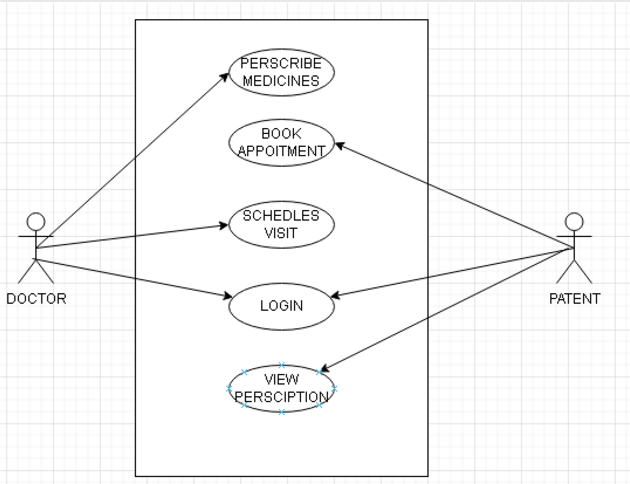**\**

# • DB DIAGRAM

## TABLE NAMES:

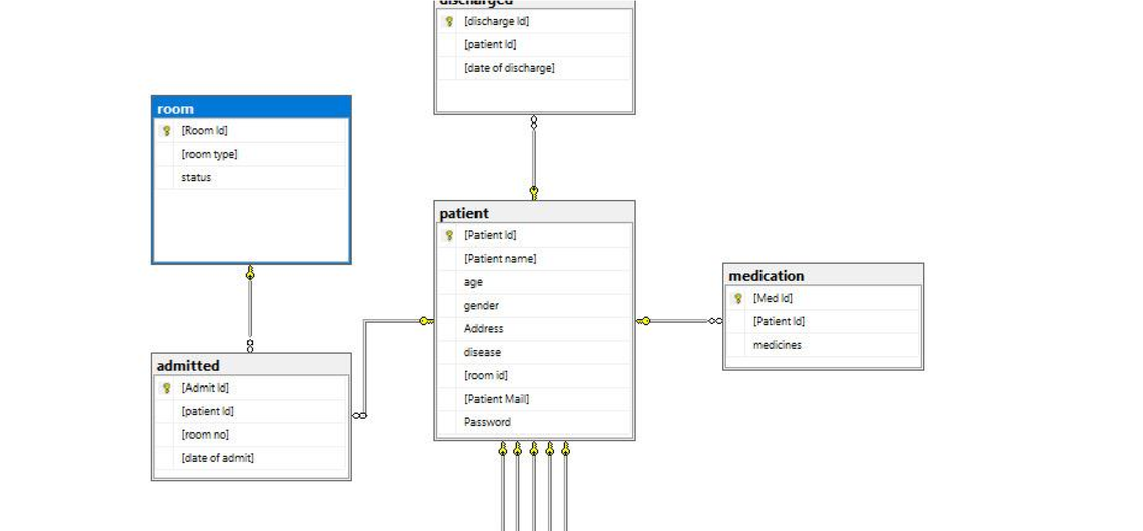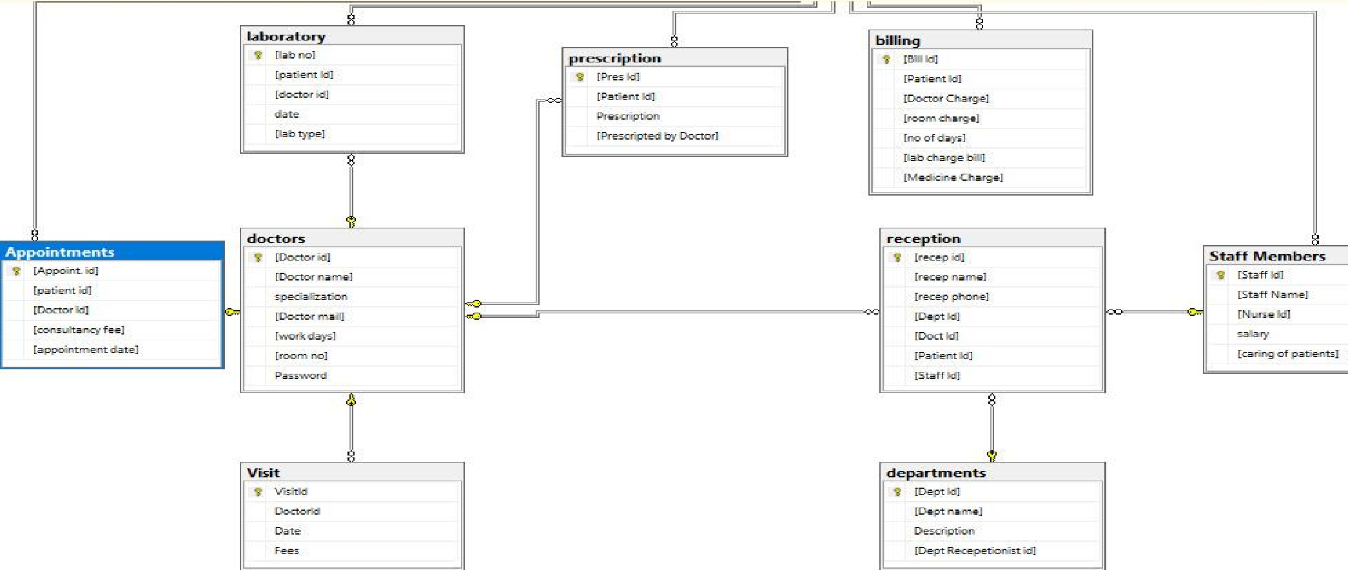

1. **Discharged**
2. **Patient**
3. **Medication**
4. **Admitted**
5. **Room**
6. **Laboratory**
7. Billing
8. Reception
9. Doctors
10. Visit
11. Appointments
12. Departments
13. Staff members

# TECHNOLOGIES

This project is a web based management system developed using C#

Compiler Visual studio. The user interface created using Visual studio GUI generator. The system created using C# Asp.net web application.

Best architecture we found for web based system is MVC architecture (model, view and controller). For storage services, we have used relational database SQL database.

## PROJECT SCREENSHOTS

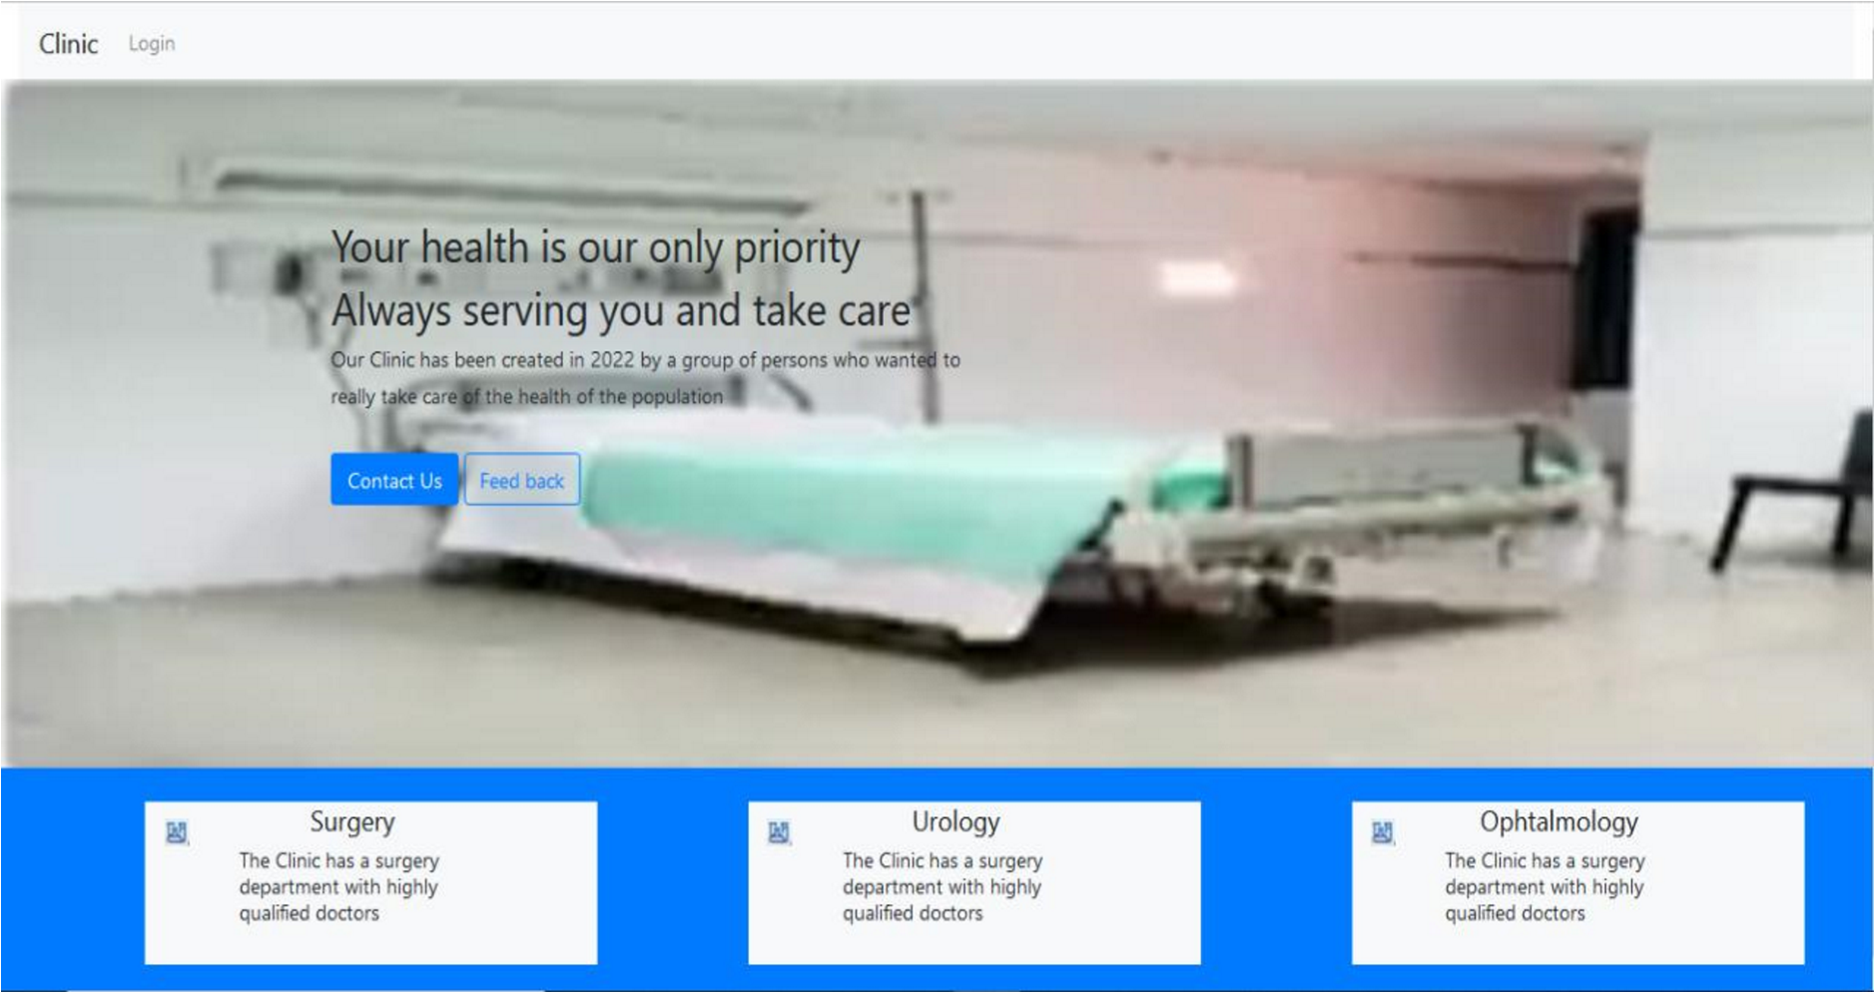

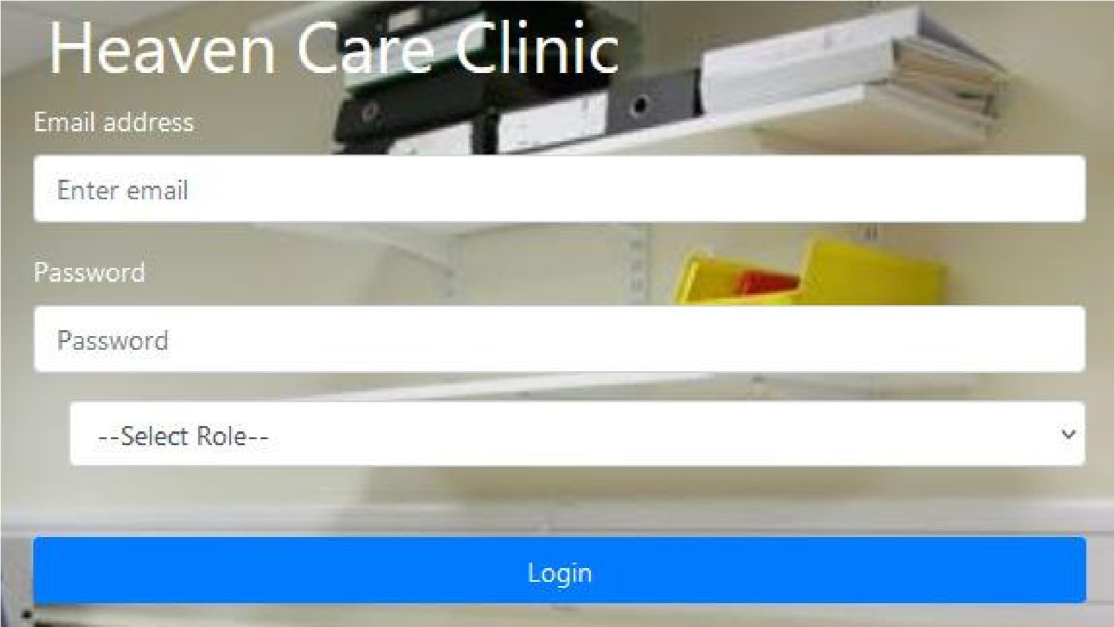

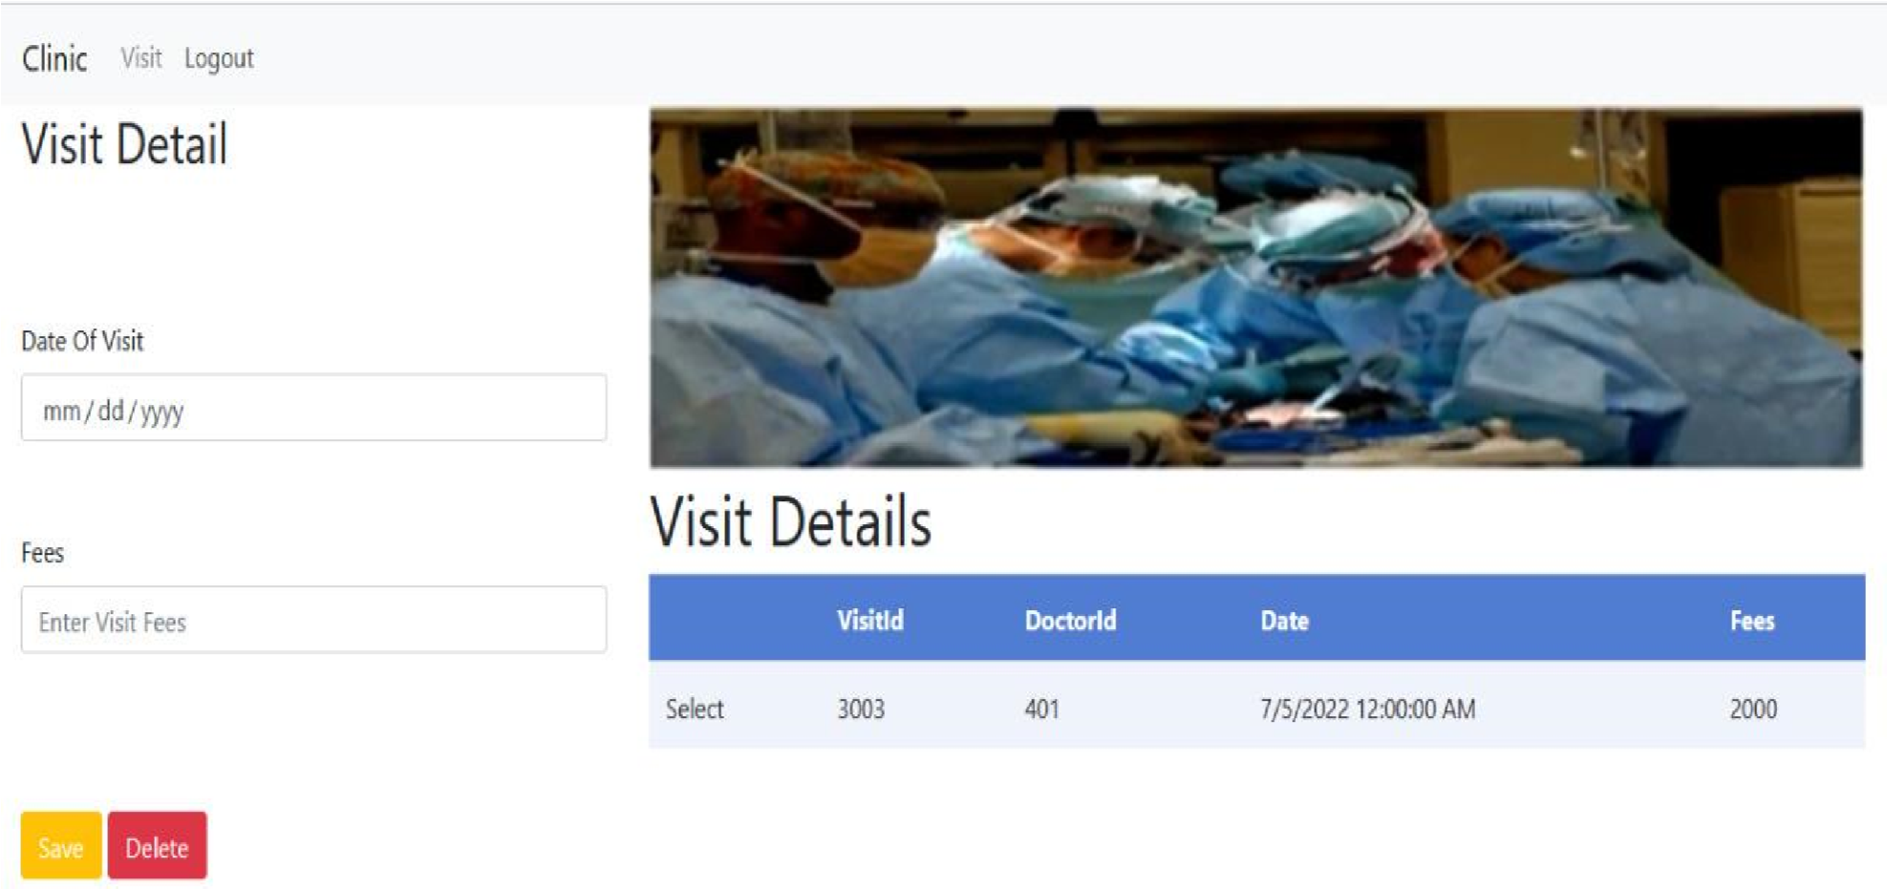

# REFERENCES:

[HTTPS://MOCDOC.IN/BLOG/A-DETAILED-VIEW-OF-HOSPITAL-MANAGEMENT-SYSTEM-HMS](https://mocdoc.in/blog/a-detailed-view-of-hospital-management-system-hms) [HTTPS://M.MU.EDU.SA/SITES/DEFAULT/FILES/CONTENT/2018/11/MAJD.PDF](https://m.mu.edu.sa/sites/default/files/content/2018/11/MAJD.pdf)